**22 JANUARY 2024 : OPTIONAL HOLIDAY FOR ALL INTERNS**

Work to be completed by interns by themselves as the company will observe optional holiday. Interns who are not present in company have to complete this work from home. React components with CSS will be covered in-depth in the session of 23 January 2024.

**TASK 1 : TYPES OF CSS ( CREATE HTML AND CSS FILE AND PERFORM BELOW CODE WITHOUT REACT )** -

Create a new folder. Inside that folder create two files ( cssexample.html and style.css )

There are three types of css

1. Inline CSS

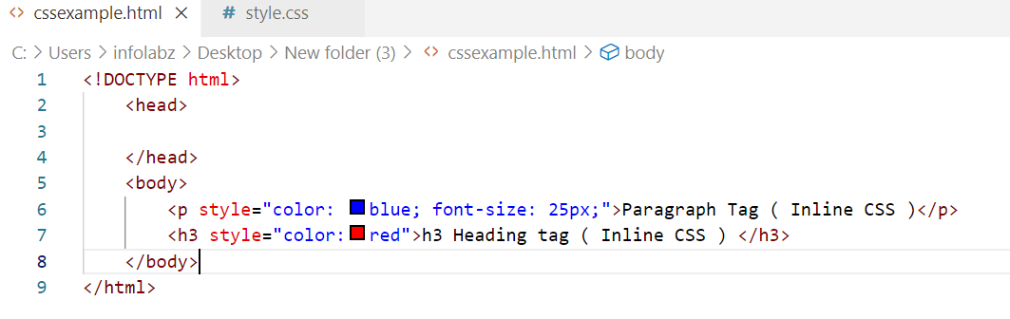

OUTPUT :

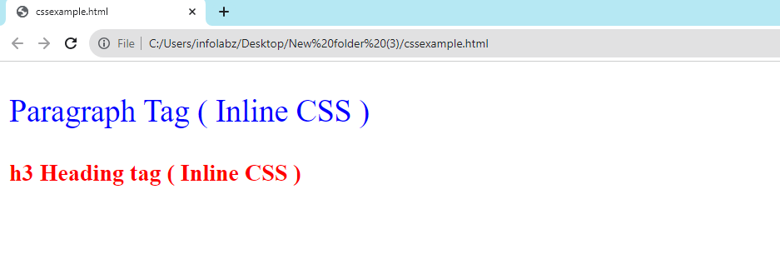

1. Document Level CSS

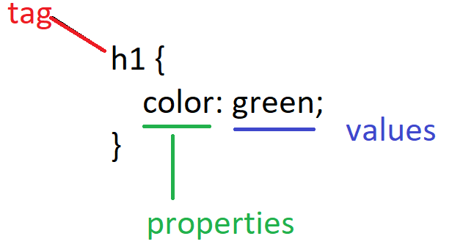

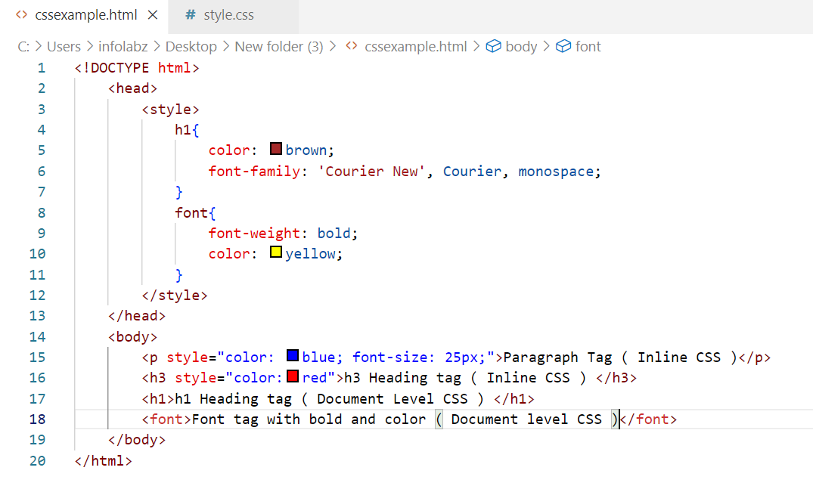

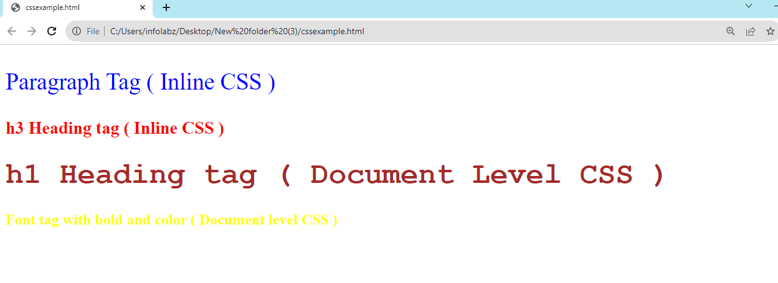

1. External CSS
2. First create style.css
3. Include in head of html file

<link rel="stylesheet" href="style.css">

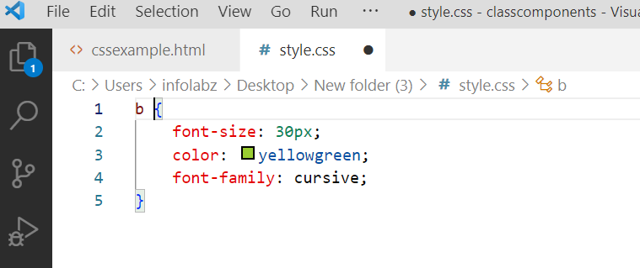

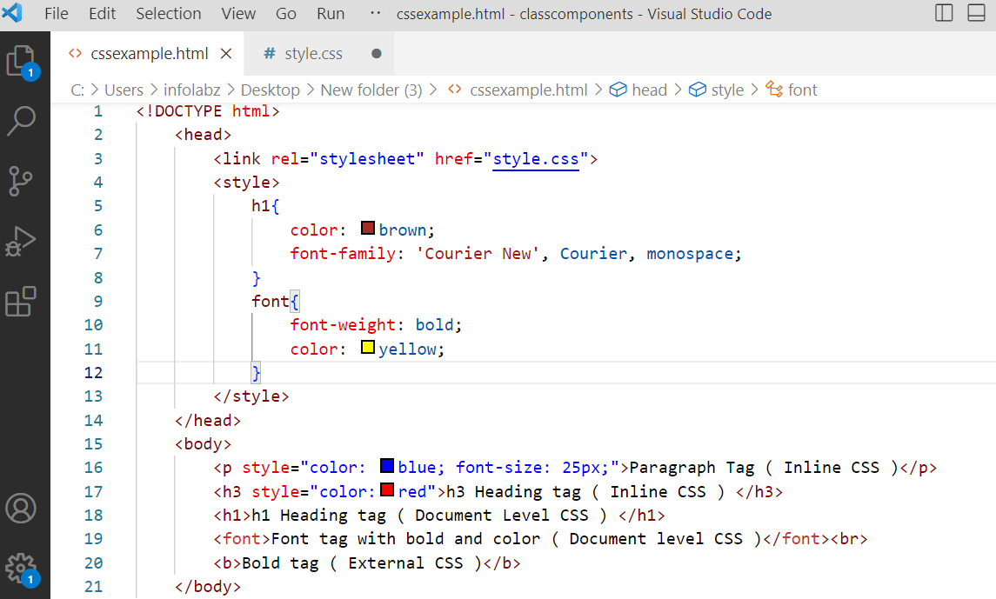

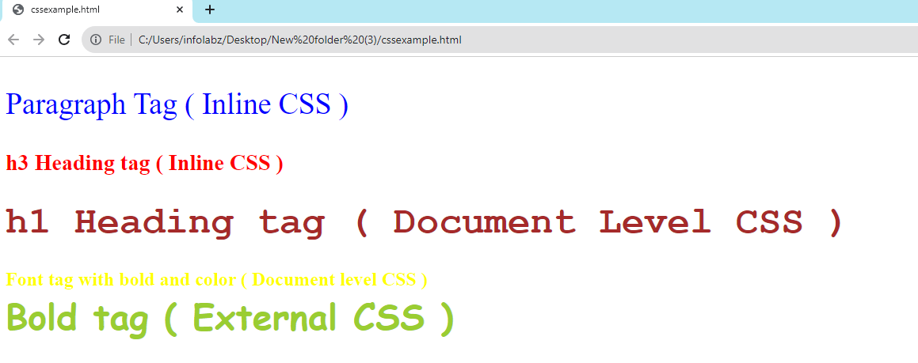

**TASK 2 : ( CREATE HTML AND CSS FILE AND PERFORM BELOW CODE WITHOUT REACT )**

Create a new html and CSS file and apply understand following types of CSS.

1. Single / Simple selector
2. Multiple Selector
3. Dedicated Class Selector
4. Universal Class Selector
5. Id Selector
6. Universal Selector

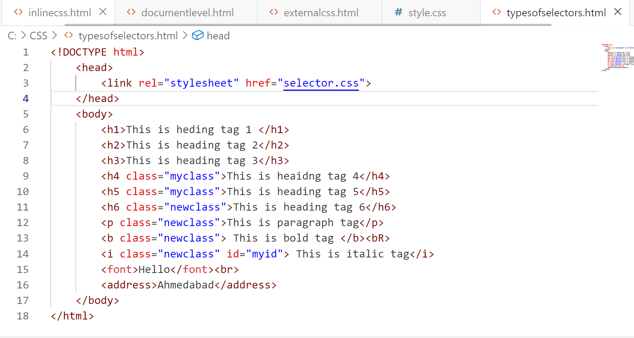

Selectors.css

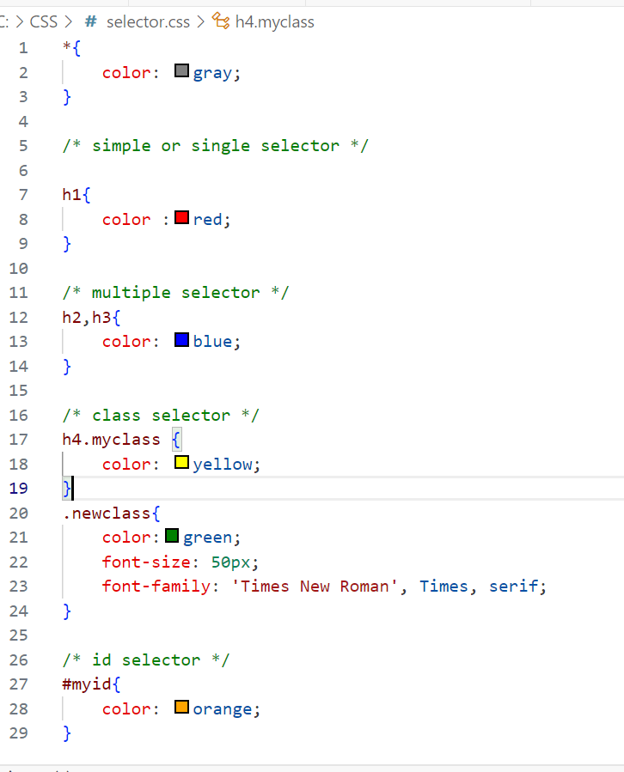

**TASK 3 : Try it yourself :**

| React Project name : functionalcompwithcss | |
| --- | --- |
| App (DE) | Add only <h1> Component with CSS </h1> |
| First (E) | Apply Inline CSS to h1 and b tag |
| Second (E) | Apply CSS in js variable and assign to i and h3 tag in component ( alternate to document level CSS as it is not supported in react ) |
| Third (E) | Apply external css to h5 and u tag |

**Solution :**

**REACT COMPONENTS WITH CSS**

Create react project : functionalcompwithcss

**Inline CSS in react :**

App.js

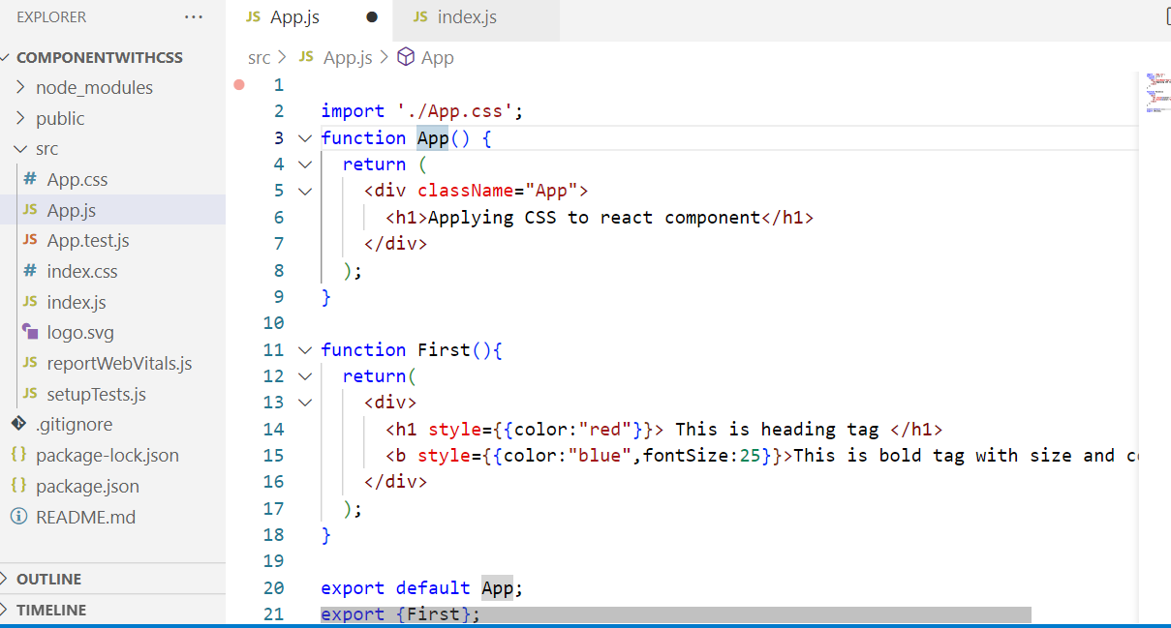

Index.js

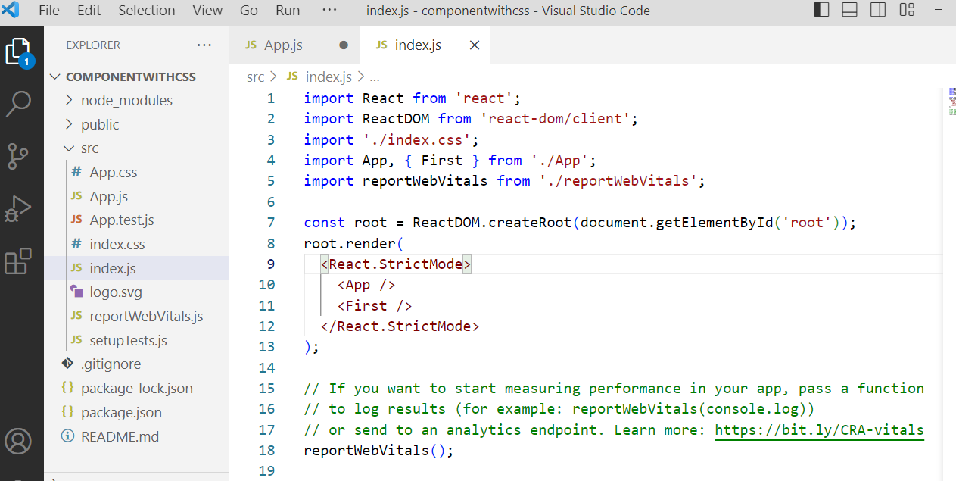

Output :

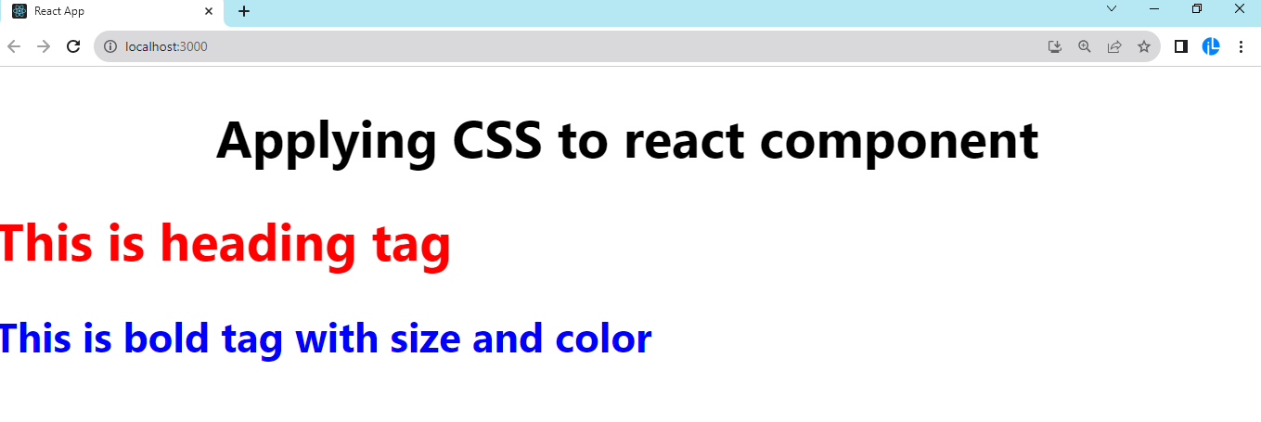

**2) Document level CSS in React**

( Logically react do not support Document Level CSS , as it do not have head part )

**App.js**

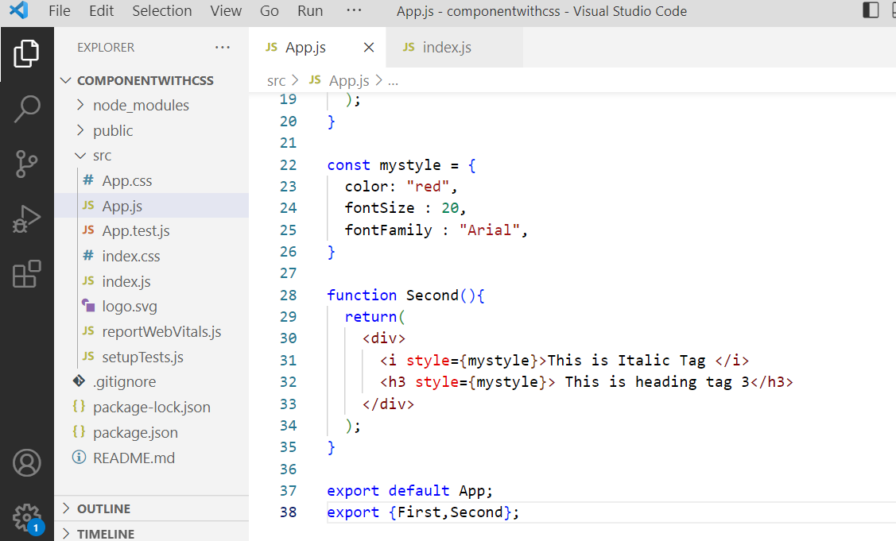

Index.js

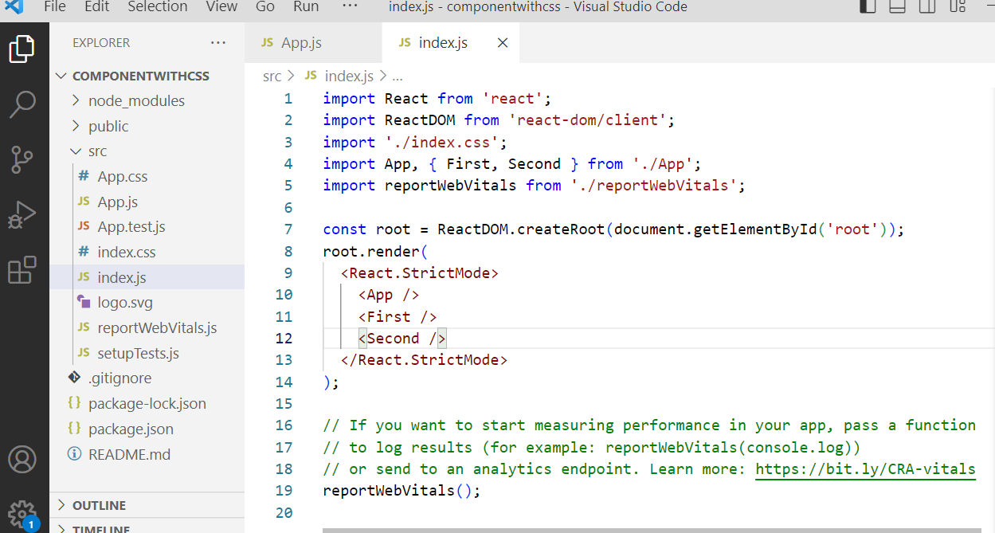

Output :

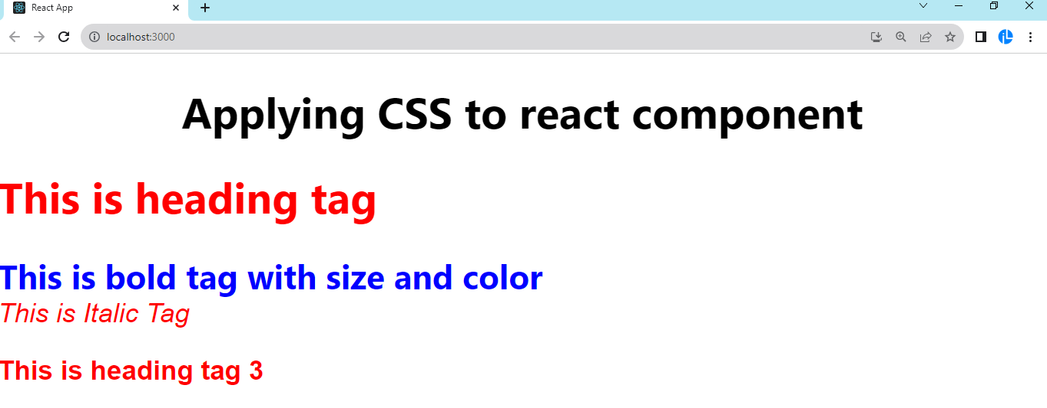

3) External CSS

1. We have to create one css file in src folder ( right click > new file > style.css )
2. Include css file in App.js

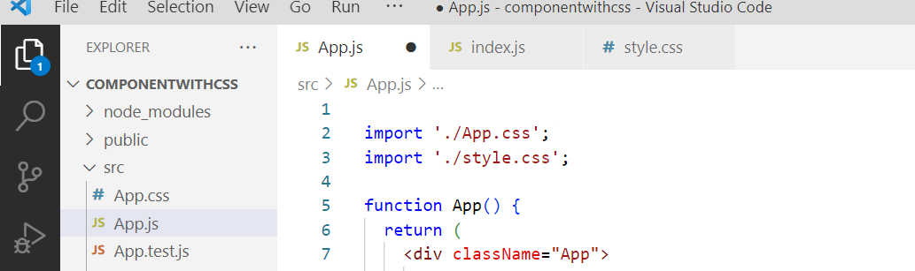

Style.css

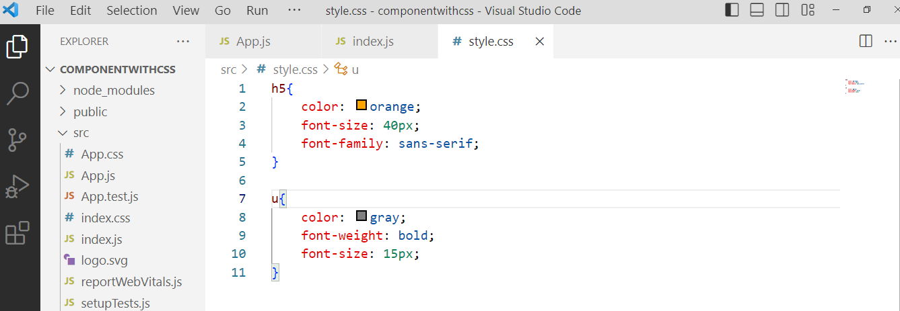

App.js

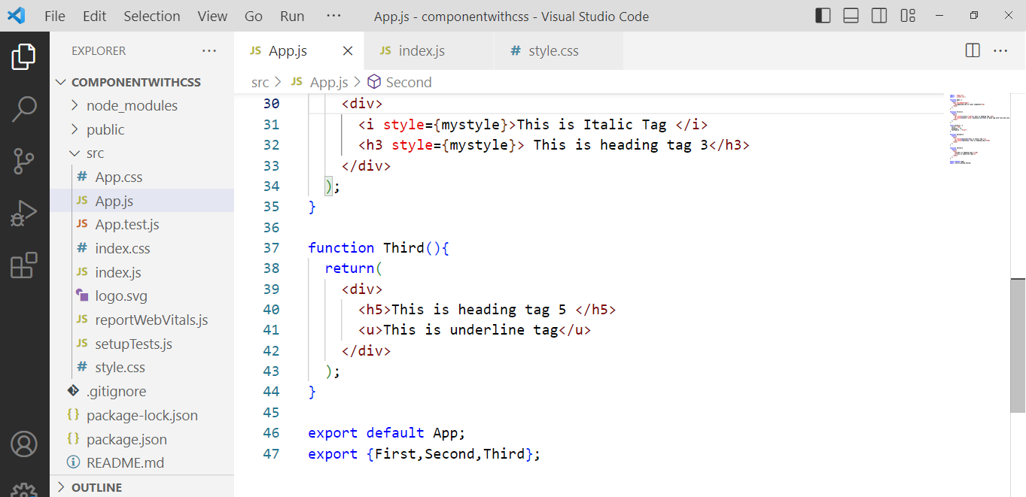

Index.js

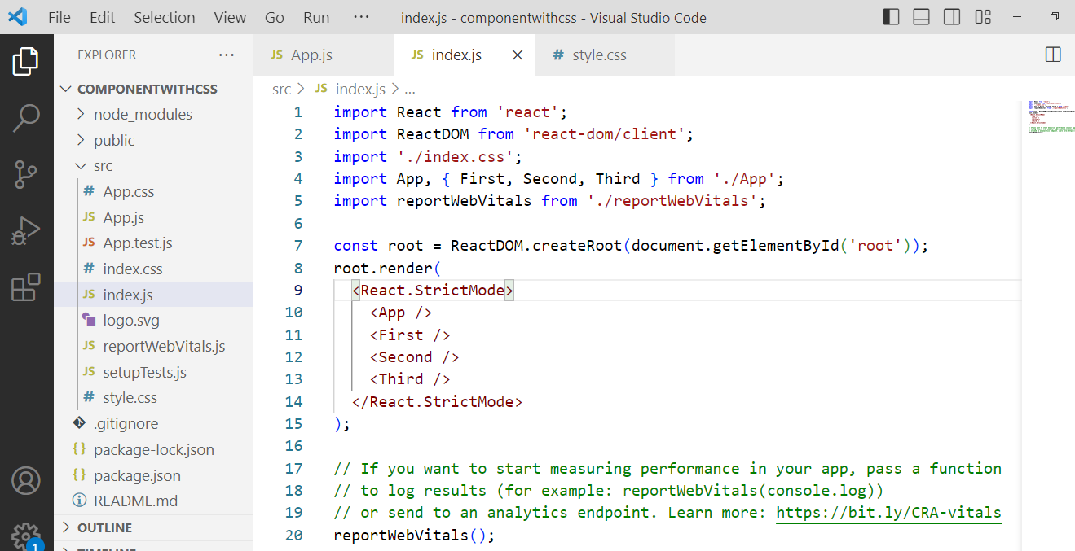

Output

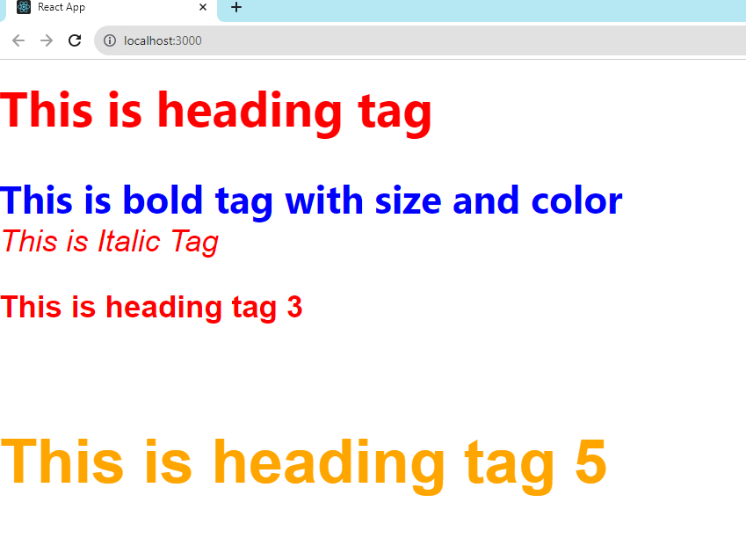

**TASK :**

| **Project Name** | reactcssone | | |
| --- | --- | --- | --- |
| **Component Name** | **Type of css** | **Use** | **Properties** |
| Login | Inline | Button | Button color : red , font on button white, add size |
| Box | external | Division | Height, width, border, radius |
| Table | Document level | Table | Border color, border thickness, font, all align center |
| One | external | Division | Box with margin, padding , height, width, border radius, border color |

|  | |
| --- | --- |
|  |  |
|  |  |
|  |  |
|  |  |